**ONLINE REVIEW DATABASE**

**TO USING MONGODB**

STUDENT NAME : Romil Moradiya

STUDENT ID : GH1041738

GITHUB LINK : <https://github.com/romil45/Mongodb_project>

VEDIO LINK :

https://drive.google.com/file/d/1i3iI_5f3SKjF34Ay4Mp4U-ceUHGUAj-H/view?usp=drive_link

**INTRODUCTION**

This project is base on online review database ,where user give their feedback toward their product and all review stored in MongoDB.in this project I have given database name **online_review_db** and I have created three table in this database the first one is **user** where I have inserted 10 recorded along with user name, user id and email id and second one is **reviews** table ,where I have put 10 recorded with id,user id ,product id ,rating ,reviews and followed by **product ,**where user see select their product details and in this table I have inserted id , name , category ,price .

**Why I have choose review database for online shopping?**

Prior to making project for MONGODB , I did not get appropriate idea for which database should make . so I just went to the internet and bumped into the one website , where I found best and productive idea to make project which has **review system** for the product and many mega companies such as a amazon and Zara based on the online review system ,where user purchase some pair of clothes and give their response toward product and reviews have totally independent if user dislike product then they have rights to give reviews and it will be best for the companies to improve their product according to the customer and eventually it will aid to booming to revenue. This is my reason to opt the database of the online review database .

**Why I have choose only three table? [user , product , reviews]**

If we want to make online review system then user and product and reviews play vital role for the database since it is mandatory without not having user and product there are not mean to store reviews in dataset while product justify the user that they buy something from the internet. Reviews base on the product and user.  
  
**Why I have opt the MONGODB for this project ?**

MONGODB is best for NOSQL and there are myriad of reason for the project

**1.Schema less design** : in MONGODB there is no required to fix schema to use and it also work in JSON to make easy query run and get flawless output without taking time

**2.Scalability.** When there are million of data stored in database that time MongoDB best for option for the handle the query without delay and data lost which is very best for the company

**3. Rapid development :** to having JavaScript and node js have lot of benefit for the database as it help to create and handle through the javascipt and node js

ER DIAGRAM

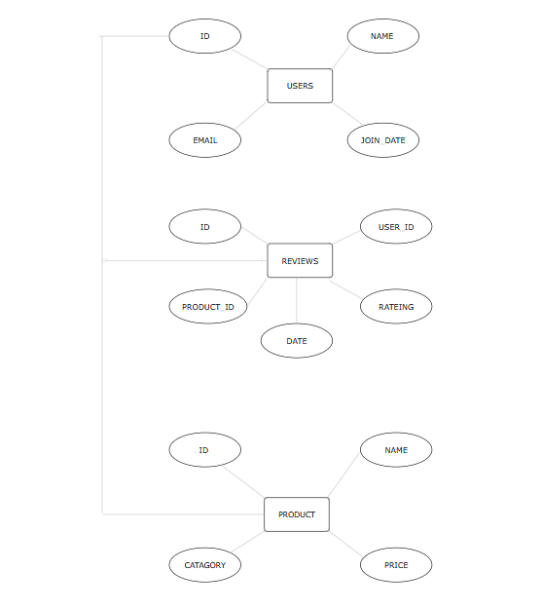

EXPLANATION OF ER DIAGRAM

THERE ARE THREE TABLE IN DATABASE

* USERS
* ID
* NAME
* EMAIL
* JOINED

**EXPLANATION :** ID is primary key for this table, which is **one to many relationship** so ID is crucial for this database.

**NAME:** user name will be stored in name

**EMAIL :** user email will be stored in email

**JOINED:** when user insert data , time will be automatically stored in database

* REVIEWS
* USER_ID
* PRODUCT_ID
* RATING
* REVIEWS
* DATE

**EXPLANATION:** ID is primary key so , when user will share their review for the product ,id will be come from the user table.

**PRODUCT_ID :** product id is key to identify the product and it will become unique for this table for easy to recognize the item

**RATING :** Rating will be given to the numerical base e.g. 1/5

**REVIEWS:** Users will be share their experience in this table

**DATE:** Date will be come from the system , where users post their reviews

* PRODUCT
* ID
* NAME
* CATEGORY
* PRICE

**EXPLANATION:** ID is primary key for database ,so this id will come from the users

**NAME :** Name is define for the different product

**CATEGORY:** Category will be upon on product if item is computer then category will be stored in electronic .

**PRICE :** Price has manually sated for different item.

**PROJECT CODE WITH SCREENSHOT**

**1.CREATE DATABASE**



**INSERT 10 DATA IN DATABASE**

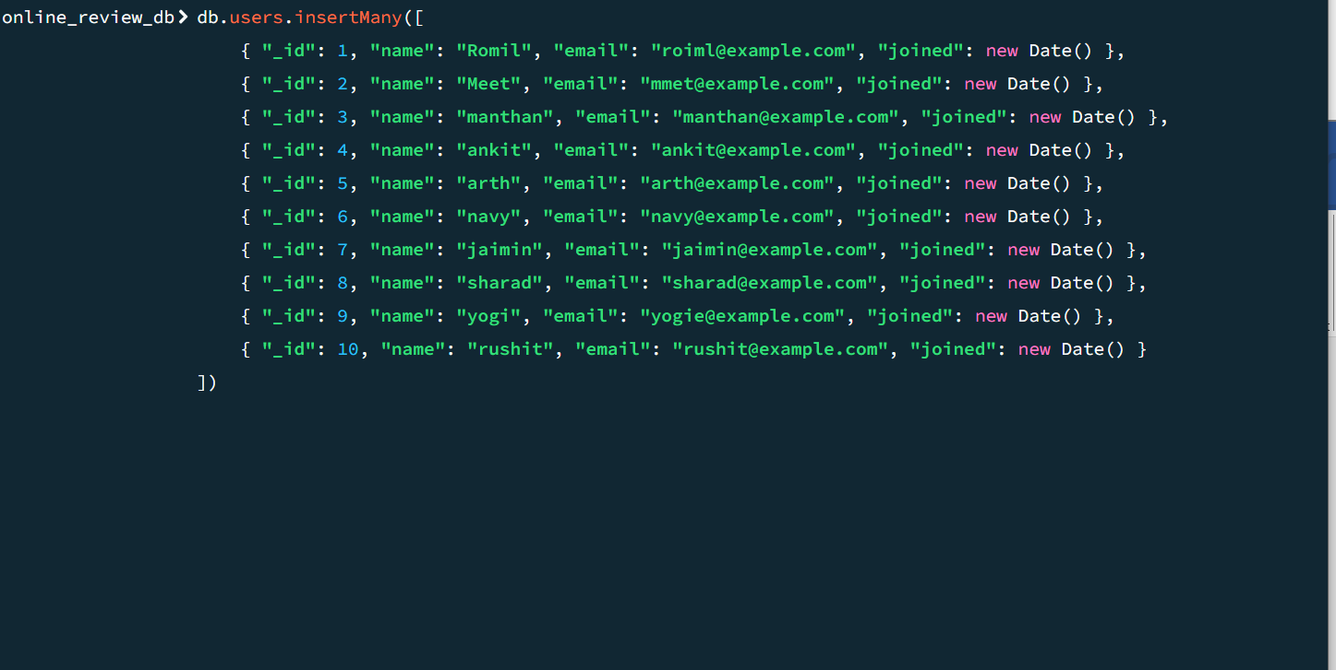

**OUTPUT:**

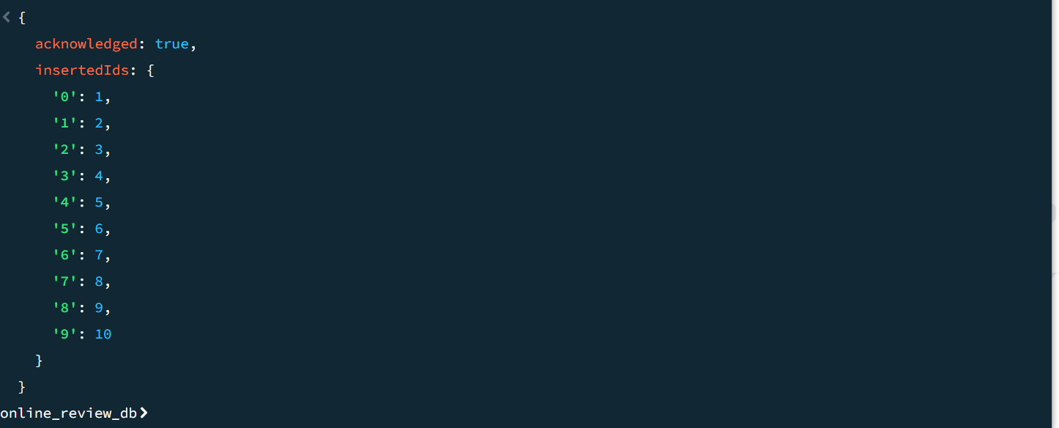

**2.INSERT PRODUCT IN DATABASE**

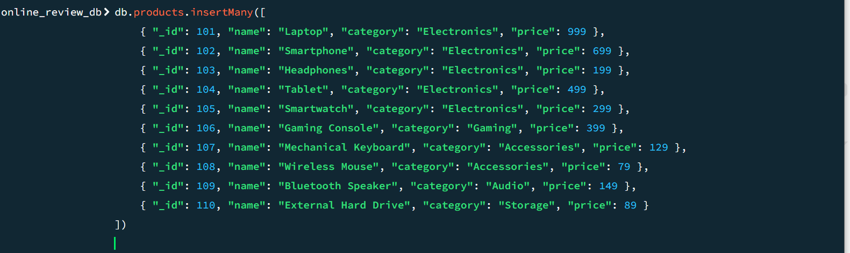

**OUTPUT:**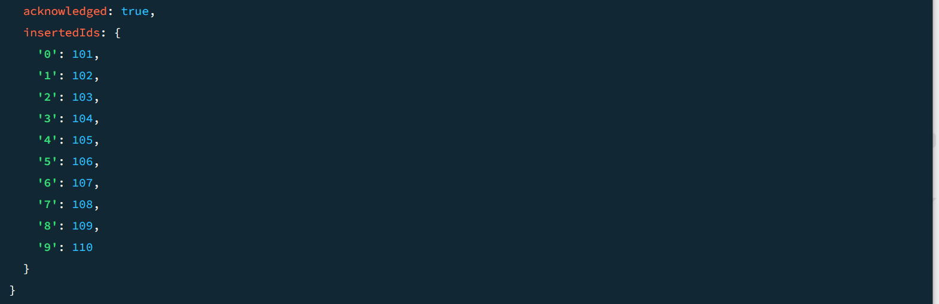

**3.INSERT REVIEWS IN DATABASE**

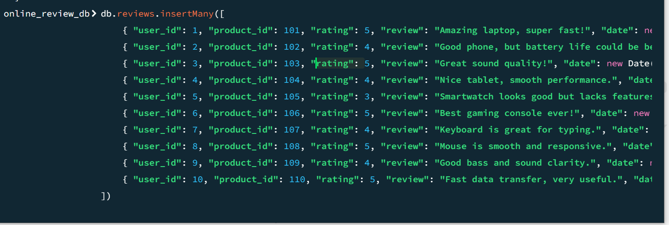

**OUTPUT:**

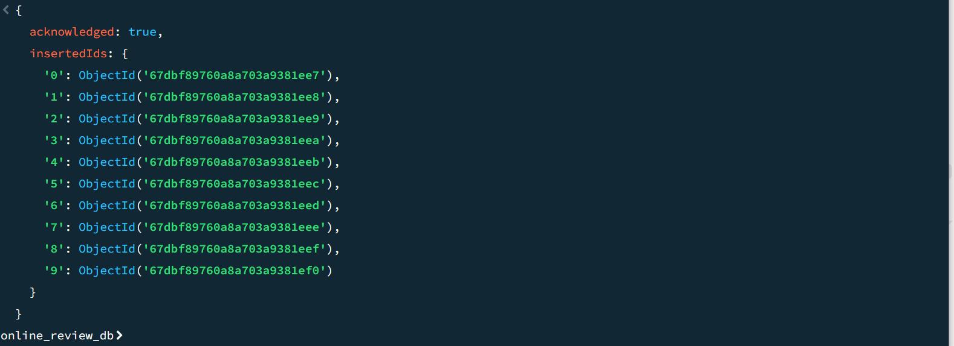

**4.TO SHOW USER FROM THE DATABASE**



**OUTPUT:**

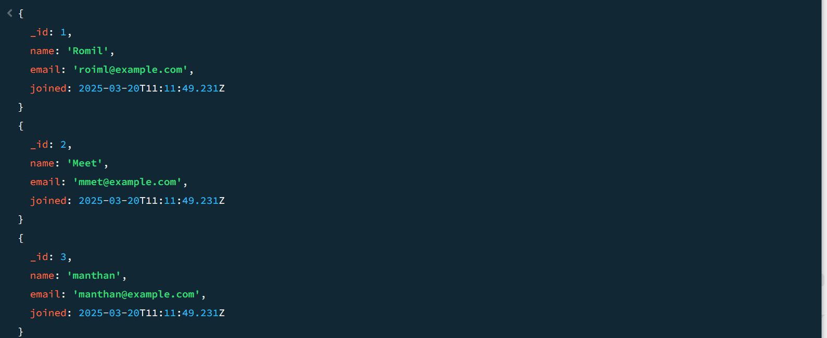

**5.TO SHOW PRODUCT FROM THE DATABASE**



**OUTPUT**

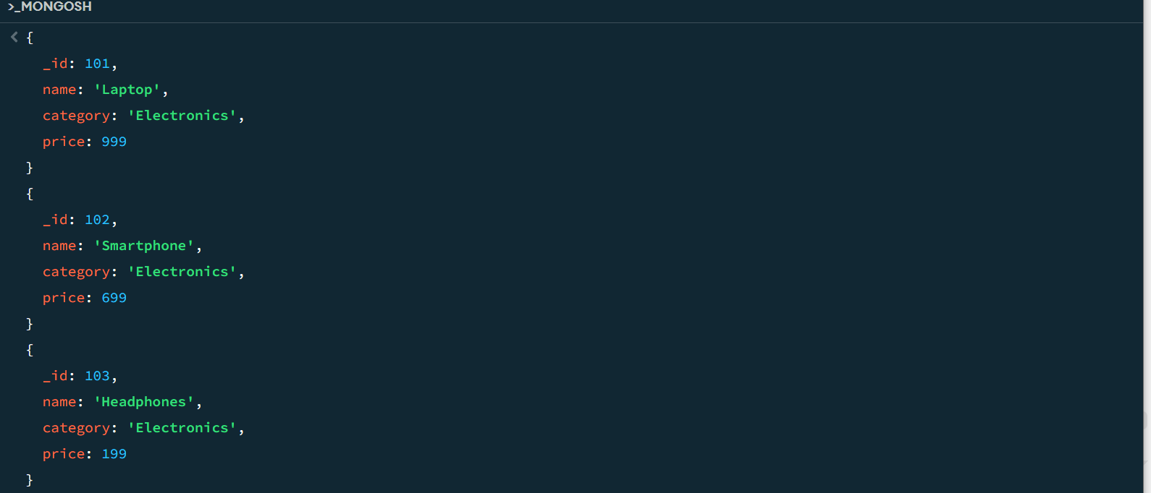

**6.TO SHOW REVIEWS FROM THE DATASBE**



**OUTPUT**

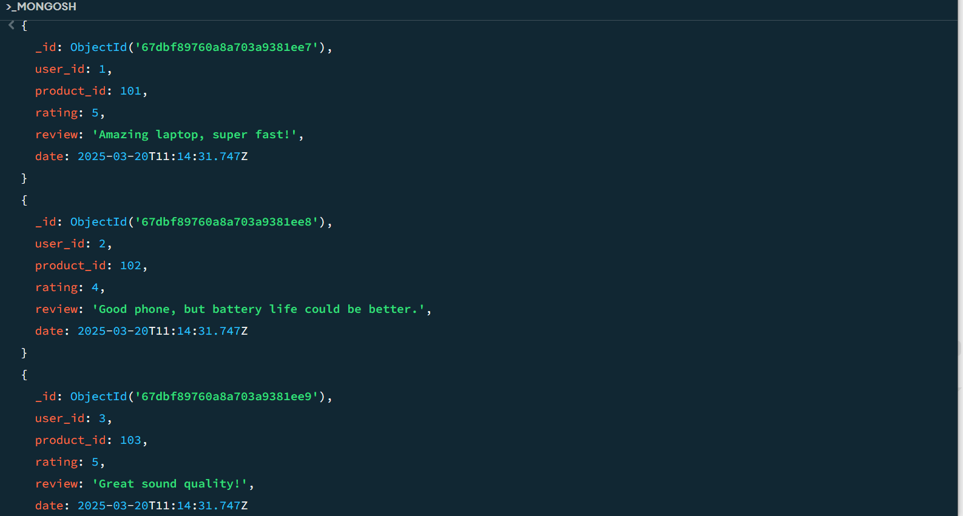

**CRUD FUNCTION IN MONGODB**

CRUD stand for the CREATE, READ, UPDATE , DELETE .

**CREATE** : if we want to create or insert new data from the user that time we can use create query which helps to insert one data instead of writing another table and it also help to many data at the same time

**READ** : It is help to read all dataset from the database to cite an epitome if stakeholder want search for particular data from the database either user that time READ function help to extract from the database.

**UPDATE :** It is help to upate data of the user , prodct and reviews if there are any errors occur that time we use update query to update data instead of create new table and insert new data

**CRUD FUNCTION WITH CODE USING JAVASCIPT**

**CREATE DATABASE:**

**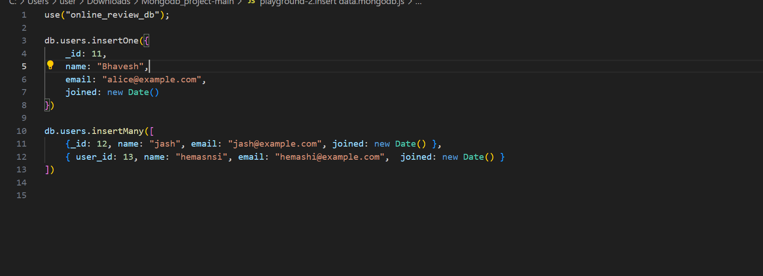  
UPDATE DATABASE :**

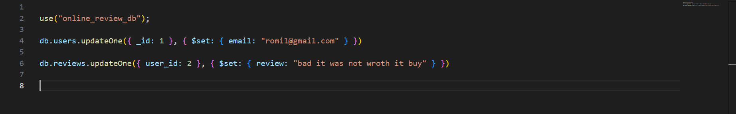

**DELETE DATASBE:**

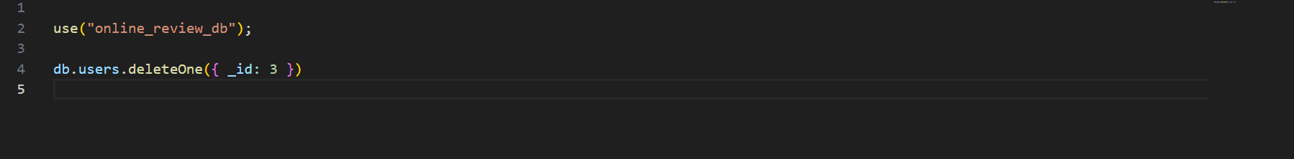

**CHALLANGING DURING MAKING THIS PROJECT**

when I have started to make the project.it seems look like easy to prepare this project. But when I reached at to make aggigation and connect database to the javascipt that time I have faced plenty of errors to run the code

these errors ranged from issues with bulid with correct database connection to problem with querying and troubleshooting these issues took significant time and effort as I had to debug the connection

**FUTURE IMPLIMANTATION IN THIS PROJECT**

In this project I will create more table such as transaction , user can add the more review and add more item through the MongoDB in order to make smooth instigation with data It would be best way to understand and making flawless.

One key addition will be transaction table designed to track and manage all user providing both transparency and purchase and action are logged providing both transparency and accountability furthermore users will be able to submit more reviews and add additional items to the system through MongoDB

Finally I will focus on the developing an admin panel where clint can oversee the reviews items and transaction ensuring the platform runs smoothly and efficiently this will also help with data analysis and repoting providing insight into user behavior sales trends and system performance